**How to use**

This project aims to manage financial market data and brokerage firm operations using a relational database system. The queries are designed for MySQL, so if they do not work using a different SQL DBM system then try them again in MySQL.

* **Stocks**: Stores information about individual stocks.
* **DailyStockMetric**: Records daily metrics for each stock
* **Transactions**: Tracks transactions involving stocks
* **Accounts**: Manages customer accounts
* **StockHolding**: Stores information about the stocks held in each account
* **Customers**: Stores customer information

Navigate to the project directory and locate the /sql_files/ directory.

Execute the commands in the following .sql files in this order:

**Create the database:** /sql_files/create_db.sql

**Insert stocks:** /sql_files/insert_company_ and_stocks.sql

**Insert daily metrics:** /sql_files/insert_daily_metrics.sql

**Insert the customers and accounts:** /sql_files/insert_customers_and_accounts.sql

**Insert transactions and holdings:** /sql_files/insert_transactions_and_holdings.sql

**Perform various queries on the database:** /sql_files/example_queries.sql

**Stock Metrics Retrieval (Optional)**

Along with the SQL commands, there are two Python scripts provided to download historical stock data and generate SQL commands to insert that data into the database.

* Install the required Python packages: pip install yfinance
* Run the data download script from the project's home directory (do not navigate to /stock_data): python /stock_data/download_stock_data.py
* The script will download historical stock data for the specified stocks and save it as CSV files.
* Run the sql insertion generator script from the project's home directory (do not navigate to /stock_data): python /stock_data/sql_insertion_generator.py
* The generated sql commands are stored in /sql_files/insert_daily_metrics.sql
* **Description**

The project's data domain encompasses financial markets and brokerage firms operating within them. A brokerage firm facilitates customers' transactions involving securities such as stocks, bonds, options, and futures. The database supports brokerage firms in managing customer accounts and transactions, as well as providing information on the securities they offer for sale.

The relationships provided below keep track of customers, customer accounts, transactions, and stock data. Each customer may have more than one account. Each account consists of transactions that involve the exchange of stock. Additionally, there is information about stocks and their daily metrics.

Data Domain:

|  |  |
| --- | --- |
| **Stock** | Stores information for stocks traded on an exchange. |
| *stock_id* | Key for table entry. |
| *symbol* | The symbol that is associated with the company name. |
| *company_name* | The name of the company that the stock represents |
| *stock_exchange* | The stock exchange that the stock is publicly traded on. |

|  |  |
| --- | --- |
| **DailyStockMetric** | Stores information about the trading day. |
| *metric_id* | Key for table entry. |
| *stock_id* | The stock associated with the metrics. Foreign key to Stock Table. |
| *date* | Date of the metric. Dates for an individual stock are unique. |
| *open_price* | Price of the stock at market open. |
| *close_price* | Price of the stock at market close. |
| *high_price* | Highest price during the trading day. |
| *low_price* | Lowest price during the trading day. |
| *volume* | Amount of shares traded during the trading day. |

|  |  |
| --- | --- |
| **Customer** | An account holder. May hold one or more accounts. |
| *customer_id* | Key for table entry. |
| *first_name* | First name of customer. |
| *last_name* | Last name of customer. |
| *email* | Email of customer. Every email is unique. |
| *date_of_birth* | Date of birth of customer. |
| *ssn* | Social Security Number for the customer. Every ssn is unique. |

|  |  |
| --- | --- |
| **CustomerExtended** | Additional customer information |
| *customer_id* | Primary key for customer extended. Foreign key to customer. |
| *address* | The address where the customer resides. |
| *city* | The city where the customer resides. |
| *state* | The state where the customer resides. |
| *phone_number* | The customer’s phone number |

|  |  |
| --- | --- |
| **Transaction** | Stores every purchase or sell an account has made. |
| *transaciton_id* | Key for table entry. |
| *stock_id* | The stock being purchased or sold. Foreign key to the Stock table. |
| *account_id* | The account making the transaction. Foreign key to the Account table. |
| *type* | An account can either buy or sell stock. |
| *date* | Date of the transaction |
| *stock_price* | The price of one stock at the time of purchase. |
| *quantity* | Number of stocks purchased for this transaction. |

|  |  |
| --- | --- |
| **Account** | Customers hold accounts that can store stock and/or currency. |
| *account_id* | Key for table entry. |
| *date_opened* | Date the account was opened. |
| *date_closed* | Date the account was closed. Set to NULL if the account is open. |
| *customer_id* | The owner of the account. Foreign key to the Customer table |
| *type* | There are three types of accounts, savings, checkings, and investment. All three accounts can store currency and/or stock. |
| *name* | The name given to the account by the Customer. |
| *balance* | The amount of currency in the account. |

|  |  |
| --- | --- |
| **StockHolding** | The amount of one stock in one account. |
| *holding_id* | Key for table entry. |
| *account_id* | The account that holds this stock. |
| *stock_id* | The stock that this account holds. |
| *quantity* | The amount of stock in this stock holding. |
| *total_investment* | The total amount that has been paid for all stock in this account. In other words, the total cost of all transactions made for a specific account and specific stock. |

* **Relationships**

**ER Diagram**

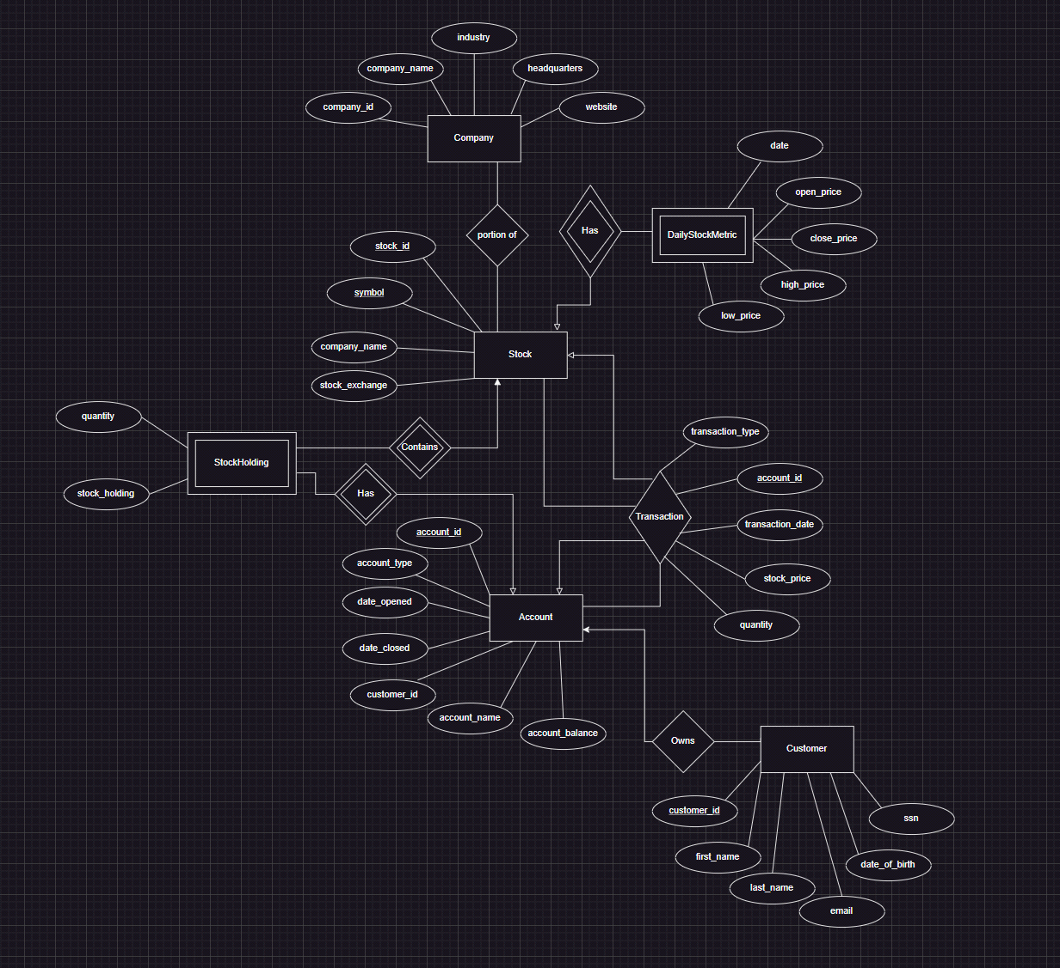

* **Entities** are represented by rectangles. These are typically the tables in a database.
* Company
* Stock
* DailyStockMetric
* Account
* Customer
* StockHolding
* Note: Transaction is not considered an entity, but rather a relationship between account and stock
* **Weak Entity** are represented by the double rectangles. Theses typically are supported by a stronger entity relation and cannot be uniquely identified based on their own characteristics.
* **Daily Stock Metric:**
* Daily Stock Metric depends on the Stock entity to exist. Its uniqueness is not established by its own attributes alone (such as the date and prices), but by its association with a Stock, referenced by the stock_id.
* The date attribute could act as a discriminator or partial key; however, only in combination with the stock_id from the Stock entity
* **Stockholding**:
* Stockholding is also a weak it is dependent on both the Account and Stock entities, with foreign keys account_id and stock_id.
* It is possible that Stockholding does not have a primary key within its own attributes, and it relies on a combination of the account_id and stock_id from the strong entities Account and Stock to uniquely identify each holding.
* **Attributes** of the entities are listed within the rectangles. These represent the columns within the tables.
* For example, the Company entity has attributes company_id, company_name, industry, headquarters, and website.
* **Primary Keys** are attributes that uniquely identify a record within an entity and are typically underlined. In this diagram, they are the first attribute listed in each entity and are used to establish relationships between the entities.
* company_id, stock_id, account_id, and transaction_id are primary keys for their respective entities.
* **Unique keys** in a database are constraints that ensure all values in a column are different from one another; no two rows can have the same value for the columns that are part of the unique key.
* company_name, email, ssn, and symbol are unique keys for their respective entities.
* **Relationships** are represented by diamonds or lines connecting entities. They define how entities relate to each other.
* For example, a Stock is part of a Company, and an Account has a StockHolding.
* **Connectors** (lines) indicate the type of relationship between entities:
* A line with a single bar at one end and an arrow at the other typically indicates a "one-to-many" relationship. The single bar indicates the "one" side, and the arrow points to the "many" side.
* Lines without arrows or bars might suggest a "one-to-one" or "many-to-many" relationship, depending on the context provided by the diagram.
* **Intersection** Entities in a many-to-many relationship are represented by a rectangle with relationships to the entities it connects.
* StockHolding seems to be an intersection entity that ties Account and Stock together.
* **Secondary Attributes** are non-primary key attributes that provide additional information about an entity.
* For example, first_name, last_name, email, date_of_birth, and ssn in the Customer entity.
* **Foreign Keys** can be inferred based on the relationships. For instance, customer_id in Account likely references customer_id in Customer.
* **Database Shema**

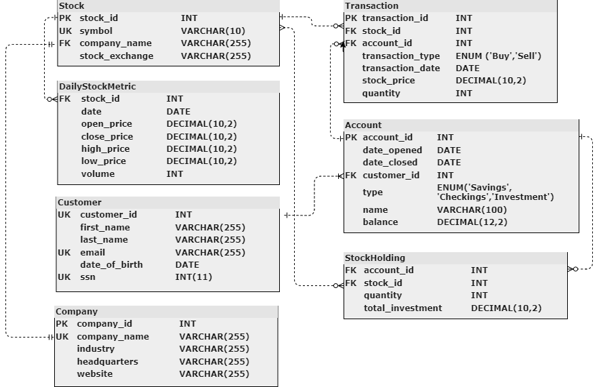

**Database diagram schema**

* **Company to Stock**:
* A one-to-many relationship exists between Company and Stock. Each company can have multiple stocks, but each stock is issued by only one company. This is why there's a foreign key (**company_name**) in the Stock entity that references **company_name** in the Company entity.
* **Stock to DailyStockMetric**:
* Another one-to-many relationship exists between Stock and DailyStockMetric. A particular stock will have multiple entries for daily metrics, one for each day, but each daily metric corresponds to only one stock, indicated by the foreign key (**stock_id**) in the DailyStockMetric entity.

**Customer to Account**:

* This relationship is also one-to-many. A single customer can own multiple accounts (savings, checking, investment, etc.), but each account is held by only one customer. The foreign key (**customer_id**) in the Account entity enforces this relationship.

**Account to Transaction**:

* Transactions are related to accounts by a one-to-many relationship. An account can have multiple transactions associated with it, while each transaction is linked to a single account, denoted by the foreign key (**account_id**) in Transaction.

**Account to StockHolding**:

* There is a one-to-many relationship between Account and StockHolding. An account can hold multiple types of stock, but each individual stock holding is associated with one account, shown by the foreign key (**account_id**) in the StockHolding entity.

**Stock to StockHolding**:

* Similarly, the relationship between Stock and StockHolding is one-to-many. A specific stock can be part of multiple holdings across different accounts, but each holding refers to one particular stock, which is why **stock_id** from the Stock entity is a foreign key in the StockHolding entity.

**Referential Integrity Constraints**

Referential integrity constraints are rules that enforce the consistency of relationships between entities. They are crucial for maintaining the correctness of a database by ensuring that foreign keys match primary keys in related entities.

In the provided E/R diagram, the foreign keys are as follows:

* **Stock (company_name) references Company (company_name)**:
* Ensures that each stock can only be associated with an existing company.
* **DailyStockMetric (stock_id) references Stock (stock_id)**:
* Guarantees that stock metrics refer to a valid stock record.
* **Account (customer_id) references Customer (customer_id)**:
* Makes sure that every account is tied to a customer who exists in the Customer entity.
* **Transaction (account_id) references Account (account_id)**:
* Transactions must be related to an existing account.
* **StockHolding (account_id) references Account (account_id)**:
* Stock holdings must be linked to valid accounts.
* **StockHolding (stock_id) references Stock (stock_id)**:
* Each stock holding must correspond to an actual stock.

**Example Query Showing Referential Constraints**

Select * From Customer, Accounts;

DELETE FROM Customer WHERE ssn = '111-11-1111';

Select * From Customer, Accounts;

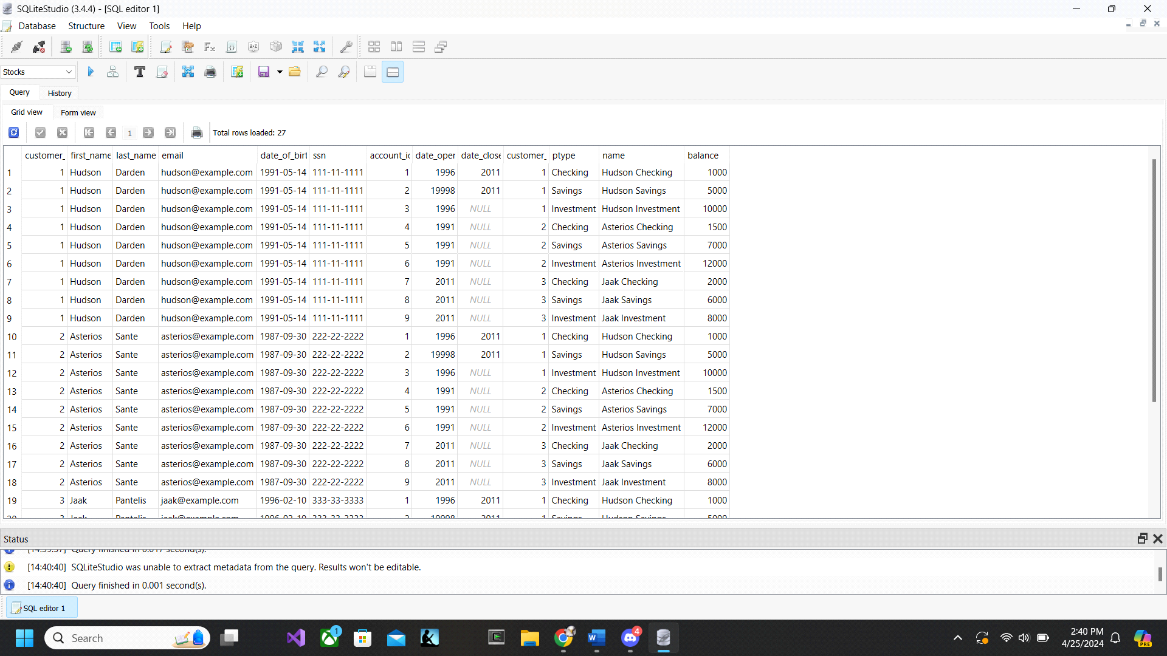

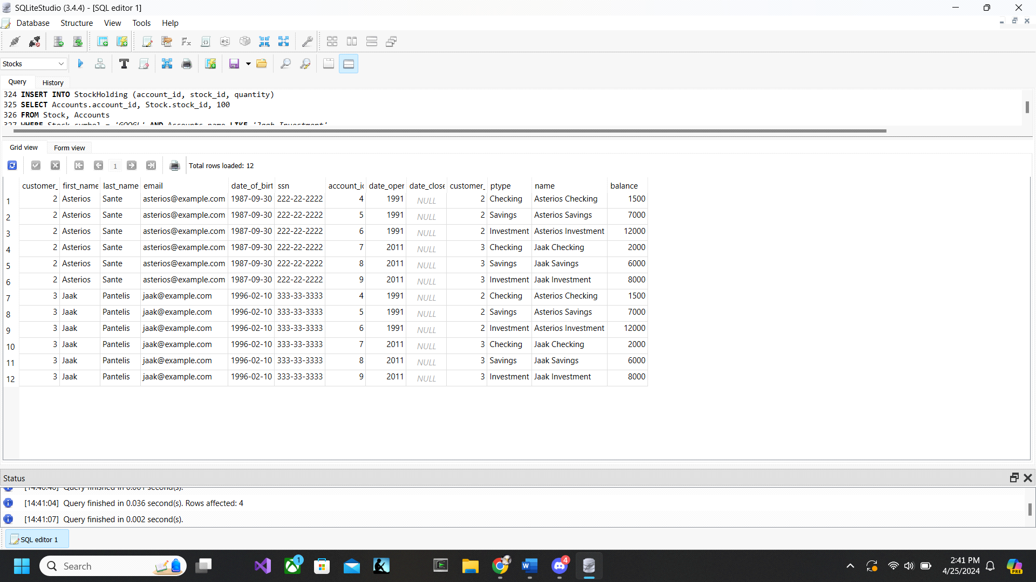

Query1 shows the cascading relationship between Customer and Account where when a customer is deleted from the Customer relationship the corresponding customer account(s) will also delete. This also applies to all reference key relationships in the database.

* **Normal Forms**

The database follows 3rd normal form, Boyce-Codd normal form, and 4th normal form. The following functional dependencies prove that the database follows Boyce-Codd Normal Form:

***Stock (stock_id, symbol, company_name, stock_exchange)***

*stock_id -> symbol, company_name, stock_exchange*

*symbol -> stock_id, company_name, stock_exchange*

From these functional dependencies it follows that both stock_id and symbol are keys. There are no other functional dependencies which proves this relation is in BCNF.

***DailyStockMetric (stock_id, date, open_price, close_price, high_price, low_price, volume)***

*stock_id, date -> open_price, close_price, high_price, low_price, volume*

This is the only functional dependency in the relation. Stock_id and date together make a key for the relation. This relation is in BCNF.

***Customer (customer_id, first_name, last_name, email, date_of_birth, ssn)***

*customer_id -> first_name, last_name, email, date_of_birth, ssn*

*email -> customer_id, first_name, last_name, date_of_birth, ssn*

*ssn -> customer_id, first_name, last_name, email, date_of_birth*

These are the only functional dependencies of the relation. Customer_id, email, and ssn are all keys. This relation is in BCNF.

***Company (company_id, company_name, industry, headquarters, website)***

*company_id -> company_name, industry, headquarters, website*

*company_name->company_id, industry, headquarters, website*

These are the only functional dependencies of the relation. Company_id and company_name are all keys, so the relation is in BCNF.

***Transaction (transaction_id, stock_id, account_id, transaction_type, transaction_date, stock_price, quantity)***

*transaction_id -> stock_id, account_id, transaction_type, transaction_date, stock_price, quantity*

This is the only functional dependency in the relation. Transaction_id is a key so the relation is in BCNF.

***Account (account_id, date_opened, date_closed, customer_id, type, name, balance)***

*account_id -> date_opened, date_closed, customer_id, type, name, balance*

This is the only functional dependency in the relation. Account_id is a key so the relation is in BCNF.

***StockHolding (account_id, stock_id, quantity, total_investment)***

*account_id, stock_id -> quantity, total_investment*

This is the only functional dependency in the relation. The combination of account_id and stock_id create a key for the relation so it is in BCNF.

When inspecting each relation in the database there are no multivalued dependencies. Each attribute of each tuple uniquely belongs to that tuple. The database conforms to 4th normal form.

* **Queries**

Below are our example queries based on the schema.

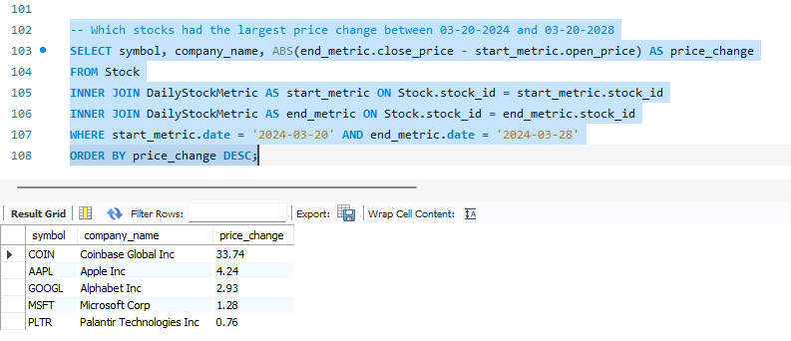

In this query, our goal is to find the stocks largest price change within a specified data. We want our output to be separated by the company symbol and name, so they are in our select. We want the price change and in a positive number so we use ABS when subtracting the close_price from open_price, in which we set both to end_mertric and start_metric respectively. We want to inner join our DSM table as both start_metric and end_metric to our Stock table to associate the stock_id from both tables. This ensures that it pulls the neccessay data from the same stock. Then we choose our specified dates from the DSM start date and DSM end date, and lastly we order them by the biggest price change to the smallest.

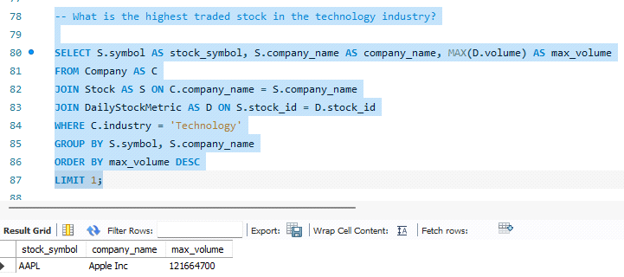

In this query, our goal was to find the higest traded stock in the tech industry. We are selecting from our table Stock, and name it as S, and grab the attributes we want to output, the symbol, the company name, and the volume, which we grab from the table DailyStockMetric we set as D. Since industry is data we need from company, we need to grab it from Company which we set as C, so we join the Stock table with the company table to get the data attribute. We set the company name from table C to be from table S so they both connect to the same company. On the otherhand, we join DailyStockMetric table with the stock table, because we also need the stock data volume to get what we want. Then we we look in the Company table where it is a 'Technology' industry and group it by the following, symbol, company name, and max volume. We set the limit of the output to only 1 because we wanted to find the highest trade stock, not the highest traded stock from each tech industry.

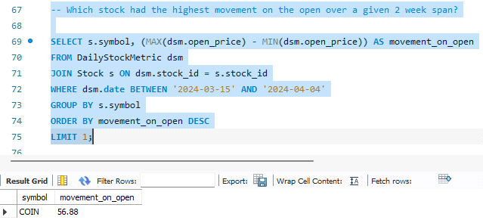

In this query, our goal was to find the stock with the highest movement on the open over a 2 week time period. We know we will need data from the stock table and DailyMetric table. For our output, we want the symbol of our stock, and the movement on open which we find by subtracting the max open price of the stock from the minimum open price. We join both tables to ensure that we are pulling data from the correct stock, we set dsm's stock id to stocks stock id to ensure this. We set a specified date of a 2 week span and group the outputs by the symbol. Since it is an aggregated query, using the MAX and MIN, we need to use the GROUP BY. We set the the limit to only 1 because we want to see the highest from all stocks.

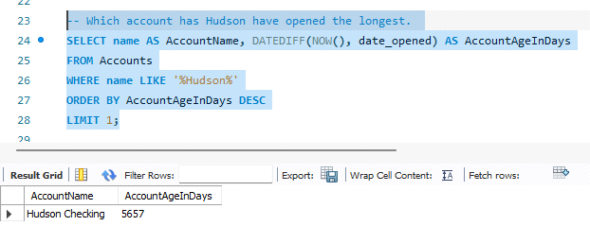

In this query, we want to see which account Hudson has opened for the longest. The data we will need stems from the Account table. We want the name and number of days in our output, DateDiff subtracts the dates of today's date which is NOW() from the date_opened which is data from the Accounts table. We set a constraint where the name is like '%Hudson%', because we want to consider the three accounts, 'Hudson checkings','Hudson savings',and 'Hudson investment'. This will ensure that it will take the name which has the word "Hudson..... " and not any of the other accounts from the other customers Jaak and Asterios. We then order it by the largest, and limit it to one because we want to see only the longest account.

Here are some other example queries to play around with, they can also be found in our example_queries.sql file:

-- How long has the investment account for Hudson been active?

SELECT DATEDIFF(NOW(), date_opened) AS AccountAgeInDays

FROM Accounts

WHERE Accounts.name = 'Hudson Investment';  
  
  
-- How much stock does Hudson have in his investment account?

SELECT s.symbol AS StockSymbol, sh.quantity AS Quantity

FROM StockHolding sh

JOIN Stock s ON sh.stock_id = s.stock_id

JOIN Accounts a ON sh.account_id = a.account_id

WHERE a.name = 'Hudson Investment';

-- What is the average accounts life.

SELECT AVG(DATEDIFF(NOW(), date_opened)) AS AverageAccountLifeInDays

FROM Accounts;

-- Which stock do all customers own the most of? This is an aggregation query.

SELECT Stock.symbol, SUM(StockHolding.quantity) AS TotalQuantity

FROM StockHolding

JOIN Stock ON StockHolding.stock_id = Stock.stock_id

GROUP BY Stock.symbol

HAVING SUM(StockHolding.quantity) = (

SELECT MAX(TotalQuantity)

FROM (

SELECT Stock.symbol, SUM(StockHolding.quantity) AS TotalQuantity

FROM StockHolding

JOIN Stock ON StockHolding.stock_id = Stock.stock_id

GROUP BY Stock.symbol

) AS MaxQuantities

);

-- What is the total value of all stocks in all acounts owned by Asterios. This has subqeuries.

SELECT S.symbol AS stock_symbol, SH.quantity AS share_amount, A.name AS account_name, SH.quantity * (

SELECT D.close_price

FROM DailyStockMetric AS D

WHERE D.stock_id = S.stock_id

AND D.date = '2024-04-11' -- most recent date

) AS total_value

FROM Customer AS C

JOIN Accounts AS A ON C.customer_id = A.customer_id

JOIN StockHolding AS SH ON A.account_id = SH.account_id

JOIN Stock AS S ON SH.stock_id = S.stock_id

WHERE C.first_name = 'Asterios';  
  
  
-- Jaak wants to buy 10 more shares of APPL. This is a insert query.

INSERT INTO Transactions (stock_id, account_id, type, date, stock_price, quantity)

SELECT Stock.stock_id, Accounts.account_id, 'Buy', '2024-04-11', 170.00, 6

FROM Stock, Accounts

WHERE Stock.symbol = 'AAPL' AND Accounts.name LIKE 'Jaak Investment';

-- Update the Jaaks new transaction into his stockholding. This is a update query

INSERT INTO StockHolding (account_id, stock_id, quantity)

SELECT Accounts.account_id, Stock.stock_id, 10

FROM Stock, Accounts

WHERE Stock.symbol = 'AAPL' AND Accounts.name LIKE 'Jaak Investment'

ON DUPLICATE KEY UPDATE quantity = quantity + 10;

* **Application/Use Cases**

This Financial database has a multitude of uses as can be seen by the example queries. There are 2 main functions that the application provides.

* First is the ability to store and answer questions about stock data through use of the Daily Metric Table. Additional tables could be added to store quarterly and yearly financial metrics.
* Second, the database stores customer, account, and transaction information. This means that the database can serve as a backend to a brokerage firm. The firm can answer questions about its customer base and their specific needs based on the data.

As a final use case, the [GitHub repository](https://github.com/jaywhtlw45/Finance-Data-Management) contains scripts that inject data from Yahoo Finance into the database. Using this method, a firm could store historical financial data for future analysis.

* **Conclusion**

Working with a database with real data is a lot different than learning about databases in class using theory or abstractions. This relation also includes many more tables and attributes than the ones that we have seen in this class before. Building a database that is functional and can be used to gather useful data is a challenging yet satisfying process. Some challenges we had building queries were conflicts in joining tables. Sometimes queries would not work as intended, so we had to rebuild and rerun/check our tables to make sure the queries did what we intended them to do.

Just from the existing attributes, we can run queries that allow us to gather information about the types of accounts that are created, the types of customers that create those accounts, the types of stocks they hold, how stock prices change depending on the industry, which companies have had the greatest successes and failures on the stock market, and so on.

There are already many queries that can be ran using the existing database, but there is always an opportunity to expand. The more thorough the database, the more information can be determined.

* **Reference:**

<https://github.com/jaywhtlw45/Finance-Data-Management?tab=readme-ov-file#usage>